## Reports/Inventory Reports/Controlled Substance Inventory:

Request:

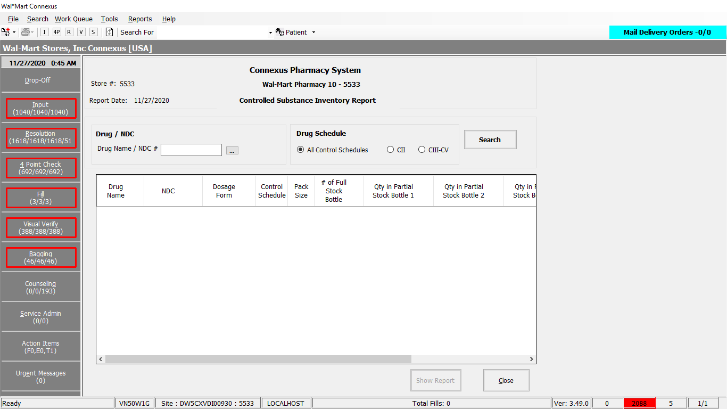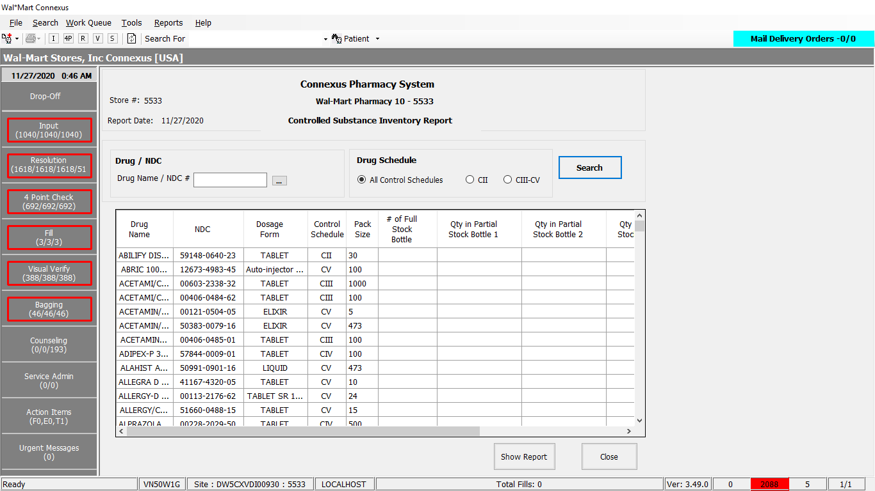

Response:

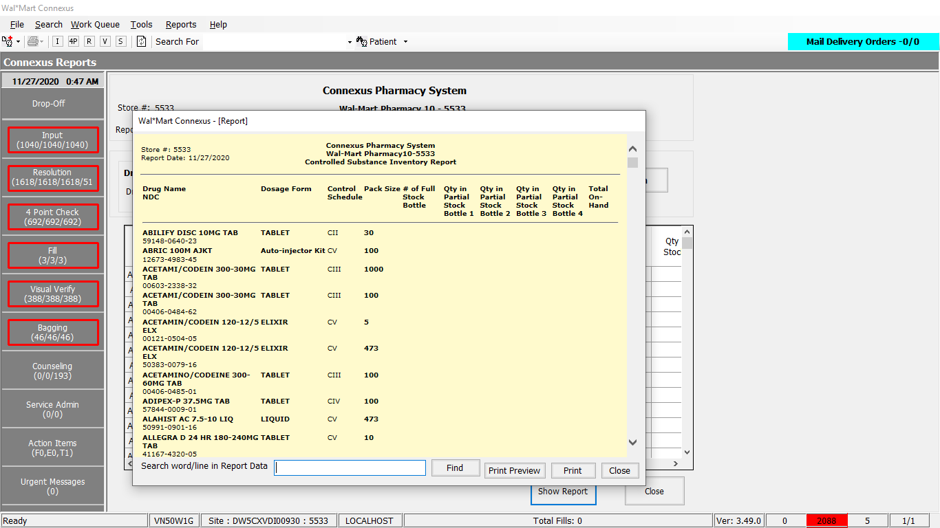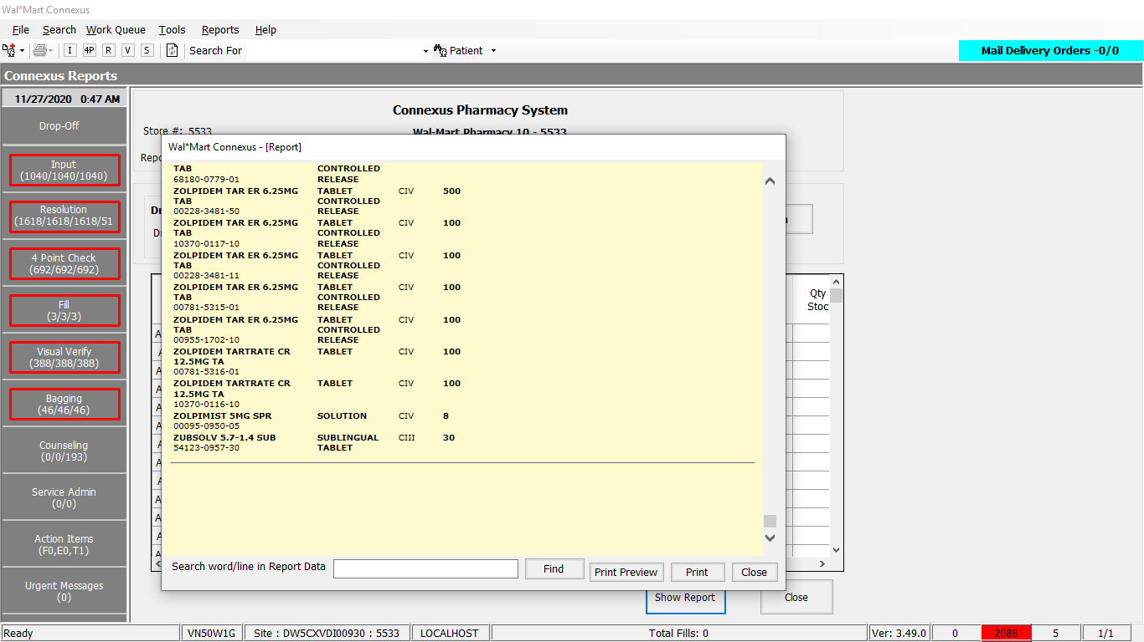

Query:

1. Friend Const ControlledSubInventoryData As String = "SELECT pp.short_name, pi.ndc_nbr,pp.drug_control_code,pd.disp_dosg_frm_desc , pi.inner_pack_qty, pp.product_mds_fam_id " &

" FROM pharmacy_offering:pharmacy_product pp join pharmacy_offering:pharmacy_item pi On pp.product_mds_fam_id = pi.product_mds_fam_id " &

" JOIN pharmacy_offering:disp_dosg_form_txt pd On pp.disp_dosg_form_cd=pd.disp_dosg_form_cd " &

" WHERE pi.on_hand_qty > 0 "

1. Friend Const onHandDrugInfoWhereDrugControlCode As String = " AND pp.drug_control_code IN ({0}) "
2. Friend Const onHandDrugInfoWhereMds As String = " AND pp.product_mds_fam_id = ?"
3. Friend Const onHandDrugInfoOrderByPName As String = " ORDER BY pp.short_name ASC, pi.on_hand_qty DESC"

DAL:

Public Function GetControlledSubInventoryData(ByVal siteId As Integer,

ByVal drugInventoryInputInfo As GetDrugInventoryValidationInputInfoBE) As List(Of GetDrugInventoryValidationInfoBE) Implements IReportDAL.GetControlledSubInventoryData

Using (New Tracer(ConnexusCommonConstants.ConnexusTracer))

Dim onHandReportQuery As New StringBuilder()

Dim controlledDrugInventoryInfoBEList As New List(Of GetDrugInventoryValidationInfoBE)

Dim paramList As New List(Of DbParameter)

onHandReportQuery.Append(ReportQueries.ControlledSubInventoryData)

'Add Where clause - Drug Schedule

If Not drugInventoryInputInfo.DrugControlCodeOption = 0 Then

Dim ControlFilter As String = ""

If drugInventoryInputInfo.DrugControlCodeOption = DrugControlCodeForDrugInventoryReport.CII Then

ControlFilter = String.Format(ReportQueries.onHandDrugInfoWhereDrugControlCode, ServicesCommonConstants.DrugControlSch2)

ElseIf drugInventoryInputInfo.DrugControlCodeOption = DrugControlCodeForDrugInventoryReport.ControlSchedule Then

Dim codes As New List(Of Integer)(New Integer() {ServicesCommonConstants.DrugControlSch3, ServicesCommonConstants.DrugControlSch4, ServicesCommonConstants.DrugControlSch5})

ControlFilter = String.Format(ReportQueries.onHandDrugInfoWhereDrugControlCode, String.Join(",", codes.ToArray()))

ElseIf drugInventoryInputInfo.DrugControlCodeOption = DrugControlCodeForDrugInventoryReport.All Then

Dim codes As New List(Of Integer)(New Integer() {ServicesCommonConstants.DrugControlSch2, ServicesCommonConstants.DrugControlSch3, ServicesCommonConstants.DrugControlSch4, ServicesCommonConstants.DrugControlSch5})

ControlFilter = String.Format(ReportQueries.onHandDrugInfoWhereDrugControlCode, String.Join(",", codes.ToArray()))

End If

onHandReportQuery.Append(ControlFilter)

End If

'Add where clause - ProductId

If Not drugInventoryInputInfo.ProductMdsFamId = 0 Then

onHandReportQuery.Append(ReportQueries.onHandDrugInfoWhereMds)

paramList.AddParameter(DbType.Int32, drugInventoryInputInfo.ProductMdsFamId)

End If

'Add Order By

onHandReportQuery.Append(ReportQueries.onHandDrugInfoOrderByPName)

Dim dataReader As IDataReader =

ExecuteReader(Common.DatabaseEnum.Pharmacy_Offering, siteId, onHandReportQuery.ToString(), paramList)

Dim controlledDrugInventoryInfoBE As GetDrugInventoryValidationInfoBE

While dataReader.Read()

controlledDrugInventoryInfoBE = New GetDrugInventoryValidationInfoBE

controlledDrugInventoryInfoBE.ShortName = SafeConvert.ToString(dataReader.GetValue(dataReader.GetOrdinal("short_name")))

controlledDrugInventoryInfoBE.NdcNumber = SafeConvert.ToString(dataReader.GetValue(dataReader.GetOrdinal("ndc_nbr")))

controlledDrugInventoryInfoBE.DrugControlCode = SafeConvert.ToInteger32(dataReader.GetValue(dataReader.GetOrdinal("drug_control_code")))

controlledDrugInventoryInfoBE.DosageForm = SafeConvert.ToString(dataReader.GetValue(dataReader.GetOrdinal("disp_dosg_frm_desc")))

controlledDrugInventoryInfoBE.PackSize = SafeConvert.ToInteger32(dataReader.GetValue(dataReader.GetOrdinal("inner_pack_qty")))

controlledDrugInventoryInfoBE.ProductMdsFamId = SafeConvert.ToInteger32(dataReader.GetValue(dataReader.GetOrdinal("product_mds_fam_id")))

controlledDrugInventoryInfoBEList.Add(controlledDrugInventoryInfoBE)

End While

If controlledDrugInventoryInfoBEList.HasRecords Then

Return controlledDrugInventoryInfoBEList

Else

Return Nothing

End If

End Using

End Function